SQL Notes

ReadMe----------------------------------------------------

**\*** Indicates definition

**!** Indicates important non definition information

----------------------------------------------------------------

# 1 Introduction:

**\* Database**:

- Any collection of related information (i.e. phone book, to do list etc). That can be stored (Paper, computer, in your mind etc)

**\* Database Management Systems (DBMS)**:

-A special software program that helps users create and maintain a database

-Advantages: Easier to manage large amounts of information, security handling, backups, importing/exporting data, ability to execute more than one program or task simultaneously (concurrency), integrates with other applications (ie programming languages). Example:

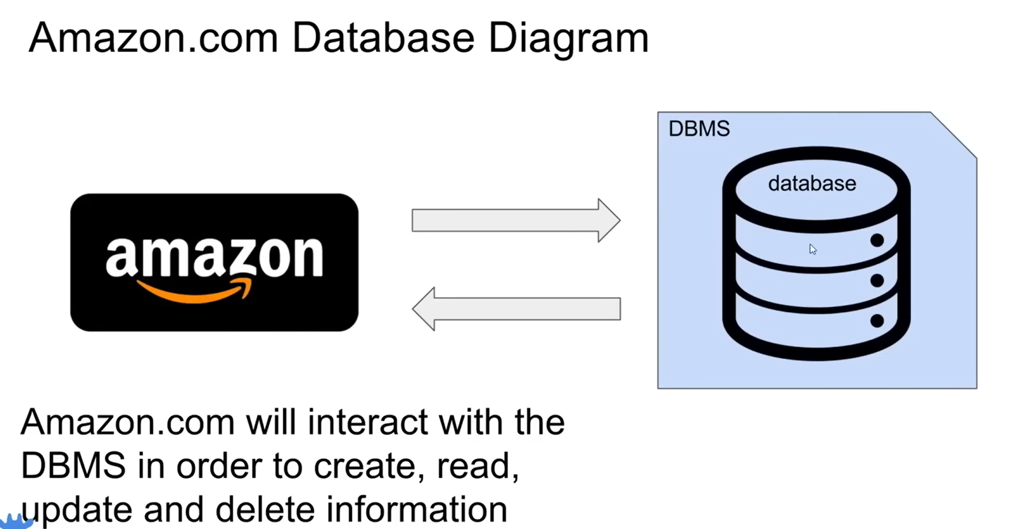

**\* C.R.U.D (C**reate **R**ead **U**pdate **D**elete**)**:

-Represents the four main operations when working with DBMS (**C**reate **R**ead **U**pdate **D**elete).

**! Two types of Databases**:

1. **\*Relational Databases (SQL)**:

- Organize data into one or more tables (each table has columns and rows and unique key identifiers)

**\*Relational Database Management System (RDBMS)**:

-Help users create and maintain a relational database (mySQL, Oracle etc)

**\*Structured Query Language (SQL)**:

-Standard language for interacting with RDBMS

-Used to perform C.R.U.D operations

-Used to perform other tasks such as backups, security and management

-Used to define table structures

2. **\* Non-Relational Databases (noSQL/ not just SQL)**:

-Organized data that is not in the form of a traditional table (key-value stores, documents, graphs, flexible tables).

Example:

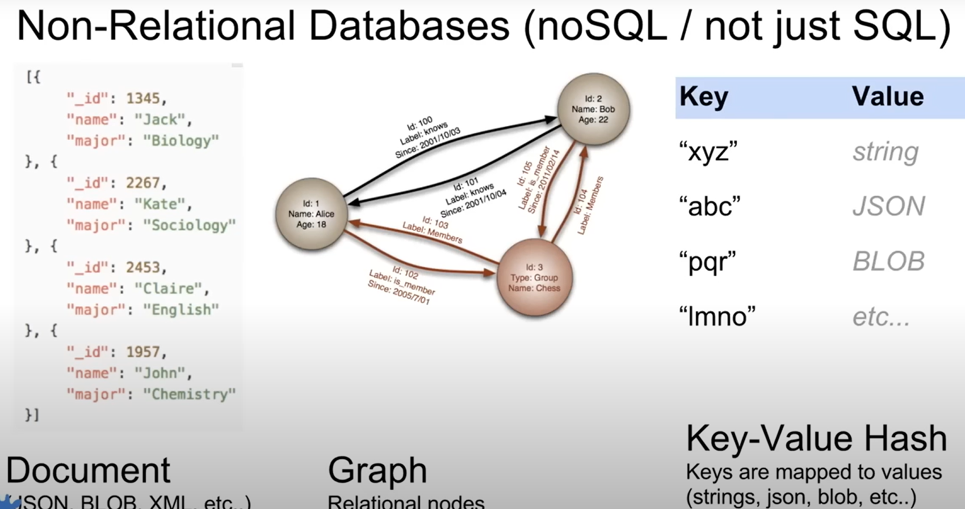

**\*Relational Database Management System (RDBMS)**:

- Help users create and maintain non-relational database (mongoDB, DynamoDB, firebase, etc)

-Implementation specific (no standard language)

**\*Database Queries**:

-Requests made to the DBMS for specific information

-Reason as database grows and becomes more complex in structure it becomes difficult to extract specific pieces of information. (Google search is a type of query)

# 2 Tables and Keys

Table example:

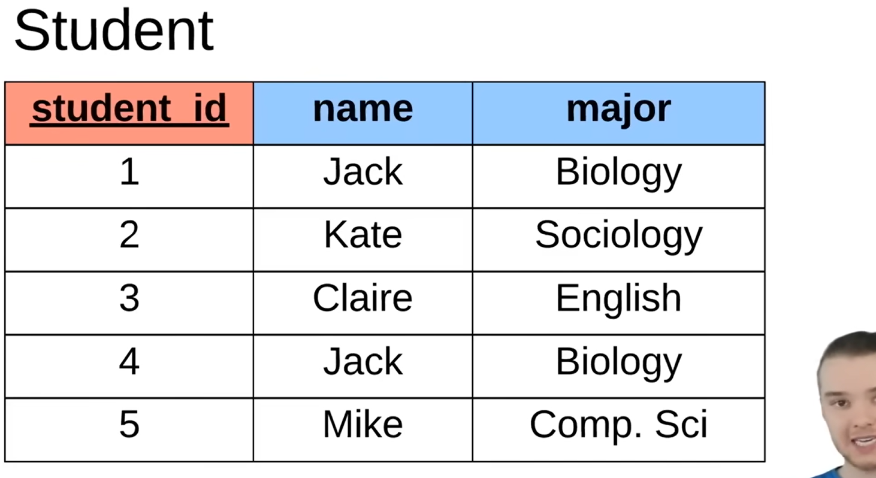

**\*Entry:** Is a row

**\*Primary key:** Attribute of an entry that is uniquely defined (in this case student_id)

(You can have surrogate keys which are artificially made identifiers and natural key where we use unique identifiers that relate to entries for example social security numbers)

Other Table example

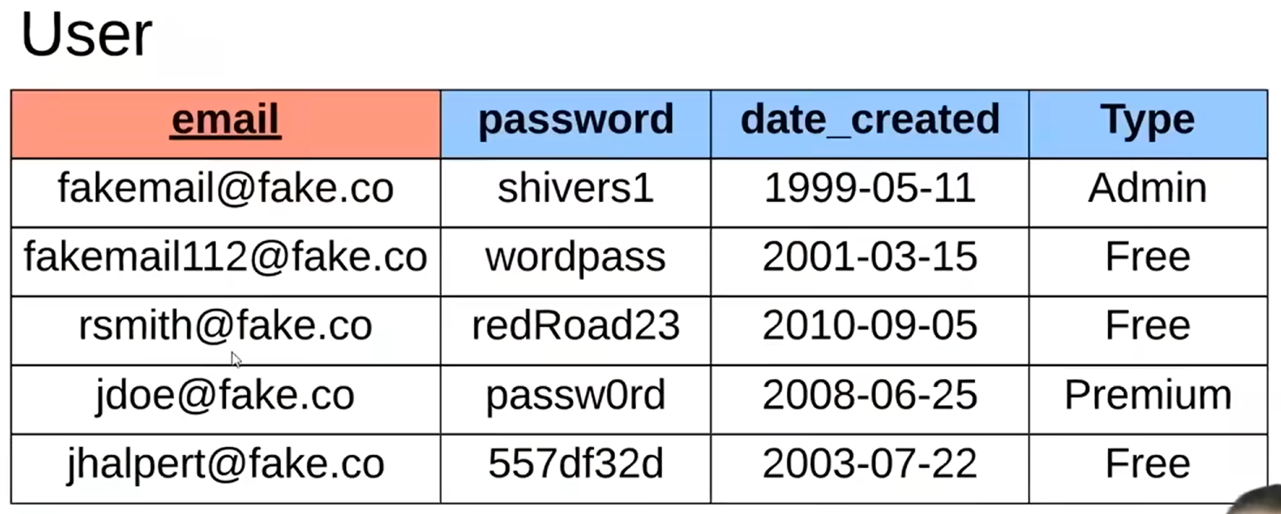

Other Table Example

Example of Table using surrogate keys:

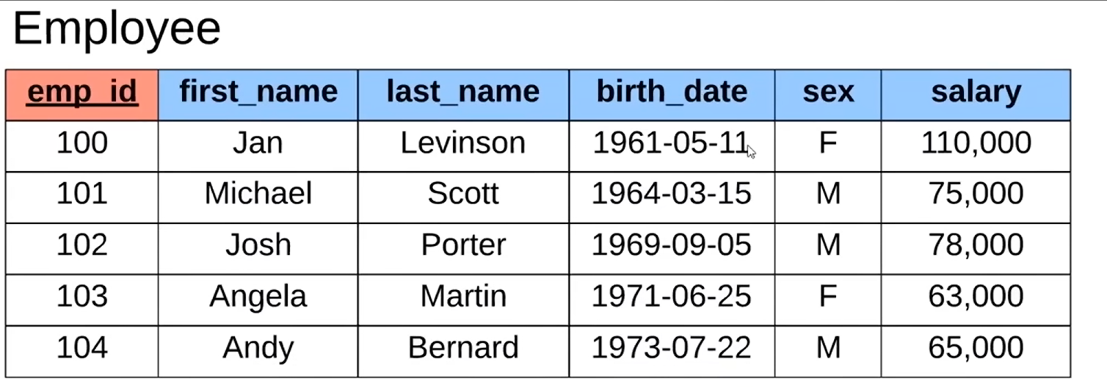

Example of Table using natural keys:

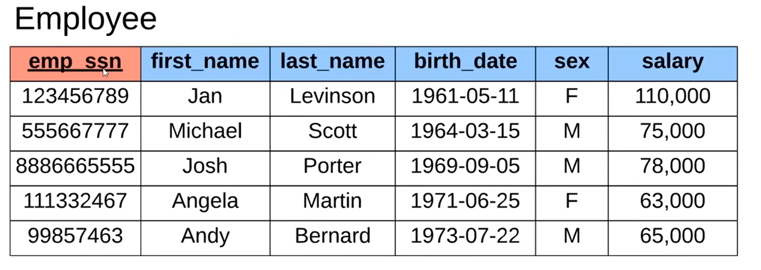

**\*Foreign key:** Attribute that links the entry to a different table.

Example (branch_id):

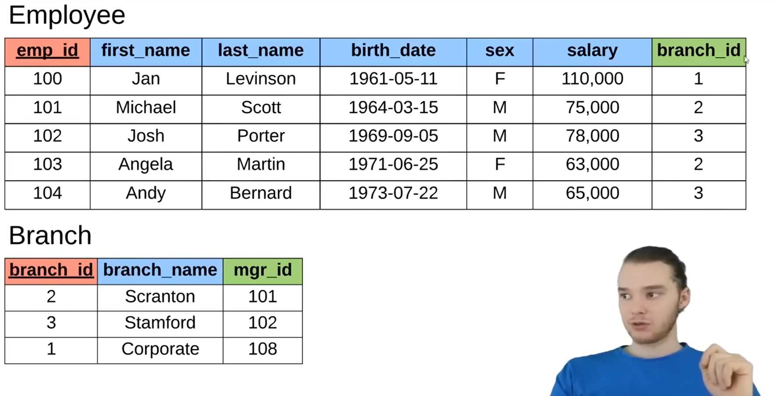

**\*Composite key:** When two columns define a unique identifier.

Example (branch_id and supplier_name):

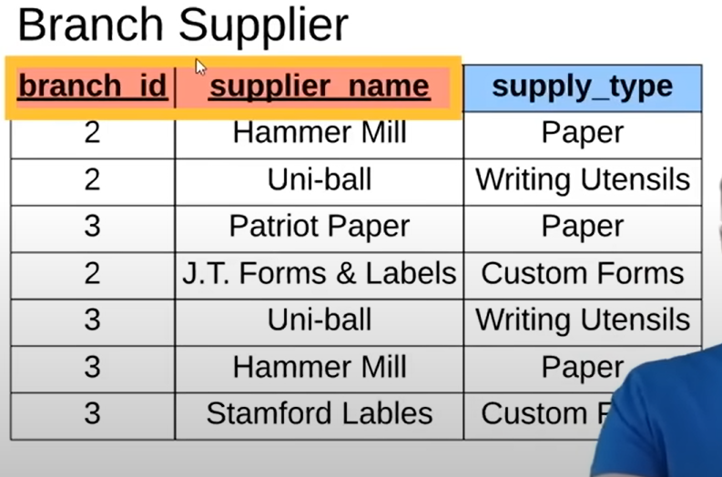

# 3 SQL Basics

**\*Structured Query Languages (SQL)**:

Recall:

-Standard language for interacting with RDBMS

-Used to perform C.R.U.D operations

-Used to define table structures

-Create and manage databases

-Used to perform other tasks such as backups, security and management

-It is a hybrid language (Data Query Language, Data Definition Language, Data Control Language, Data Manipulation Language)

! Note, that not all Relational Database Management System (RDBMS) follow the SQL standard exactly the same. (Concepts are the same but implementations vary)

**\*Queries**:

-Set of instructions given to a RDBMS that tells the RDBMS what information you will want it to retrieve for you.

# 4 SQL Commands

**Create a Database:**

mysql> create database database_name;

**Most common SQL datatypes**:  
**INT** --whole numbers

**DECIMAL(M,N)** --Decimal Numbers (exact value)

**VARCHAR(1)** --string of text of length 1

**BLOB** --Binary Large Object, Stores Large data

**DATE** --'YYYY-MM-DD'

**TIMESTAMP** --'YYYY-MM-DD HH:MM:SS'

**Create and describe Tables:**

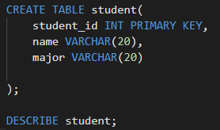

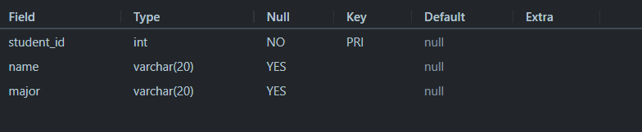

**Delete tables**:



**Alter Tables**:



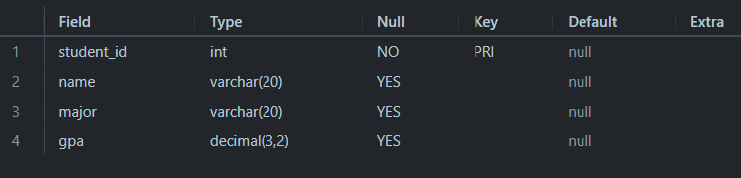

**Inserting Data and viewing all (*) data in table**:

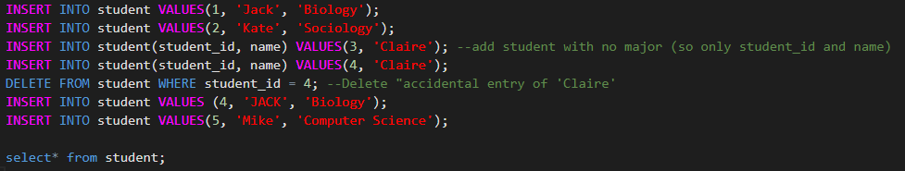

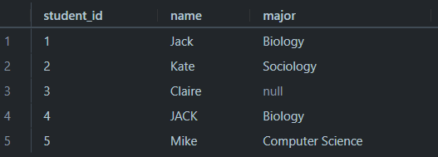

**Update Tables**:

Example where changing biology to bio

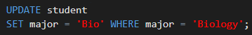

**Other useful commands**:

NOT NULL -- Ensures that no entries in this column can be NULL

UNIQUE -- Ensures that there are no duplicate instances in a column

*note that a primary key inherently possesses NOT NULL and UNIQUE constraints

Implementation example:

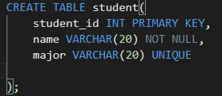

**Setting default values**:

Implementation example:

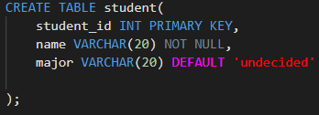

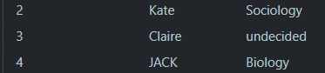

**Updating rows**:

Implementation example:

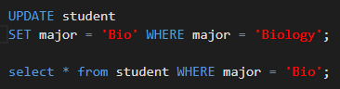

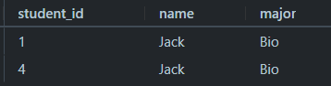

Other example:

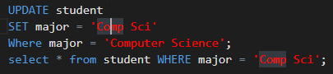

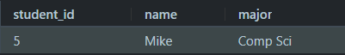

Another Example:

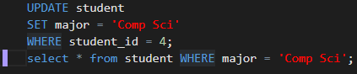

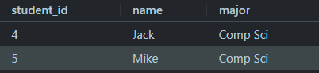

Other example:

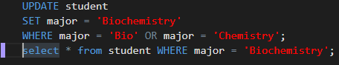

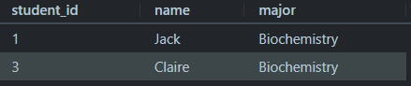

Other example:

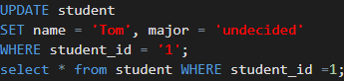

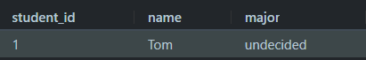

*Note a query like this:  
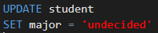

Will set all the majors to ‘undecided.

**Deleting rows**:

Delete student entry that has student id of 5…

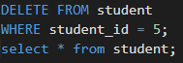

Other example:

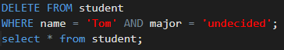

Selecting all students we have..

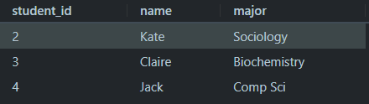

Deleting all rows…

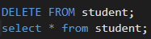



# 5 Basic Queries

Working with this table:

Selecting all columns:

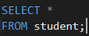…

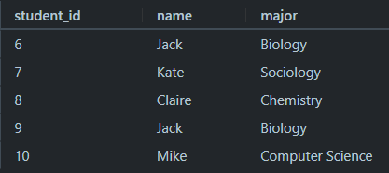

Selecting only one column:

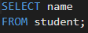

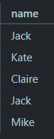

Selecting multiple columns:

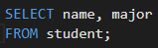

Or

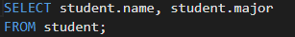

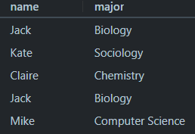

Ordering by column (by default in Ascending order):

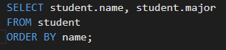

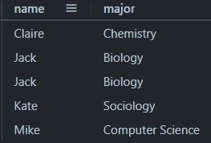

Ordering by column in descending order:

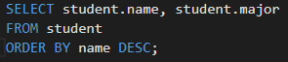

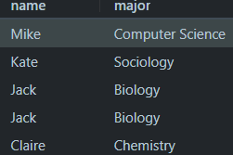

Order by column that is not selected:

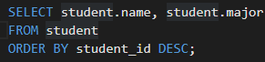

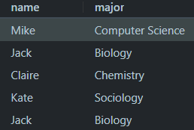

Sub ordering example:

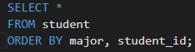

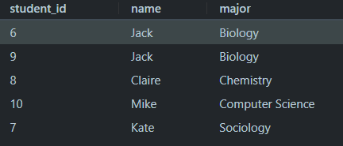

LIMIT the number of entries shown:  
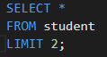

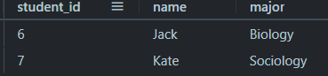

LIMIT and order the columns:

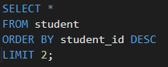

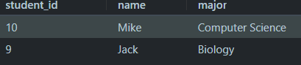

Filtering example:

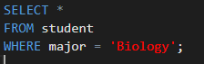

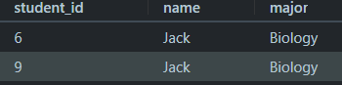

Other filtering example:  
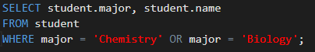

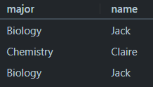

**! Comparison operato**rs:

<, >, <=, >=, =, <>, AND, OR *note <> is NOT operator

Example of <> implementation:  
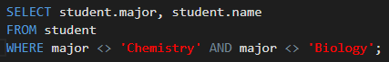

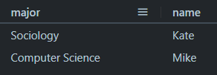

Example where we select students that have certain names:

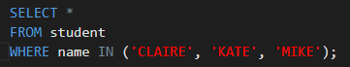

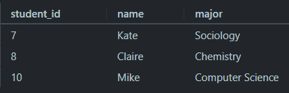

# 6 Company Database Intro

-- Create company database

CREATE TABLE employee (

  emp_id INT PRIMARY KEY,

  first_name VARCHAR(40),

  last_name VARCHAR(40),

  birth_day DATE,

  sex VARCHAR(1),

  salary INT,

  super_id INT,

  branch_id INT

);

CREATE TABLE branch (

  branch_id INT PRIMARY KEY,

  branch_name VARCHAR(40),

  mgr_id INT,

  mgr_start_date DATE,

  FOREIGN KEY(mgr_id) REFERENCES employee(emp_id) ON DELETE SET NULL

);

--ADD branch id in employee table as a forreign key

ALTER TABLE employee

ADD FOREIGN KEY(branch_id)

REFERENCES branch(branch_id)

ON DELETE SET NULL;

--ADD supervisor ids (super_id) as a forreign key in employee table

ALTER TABLE employee

ADD FOREIGN KEY(super_id)

REFERENCES employee(emp_id)

ON DELETE SET NULL;

CREATE TABLE client (

  client_id INT PRIMARY KEY,

  client_name VARCHAR(40),

  branch_id INT,

  FOREIGN KEY(branch_id) REFERENCES branch(branch_id) ON DELETE SET NULL

);

CREATE TABLE works_with (

  emp_id INT,

  client_id INT,

  total_sales INT,

  PRIMARY KEY(emp_id, client_id),

  FOREIGN KEY(emp_id) REFERENCES employee(emp_id) ON DELETE CASCADE,

  FOREIGN KEY(client_id) REFERENCES client(client_id) ON DELETE CASCADE

);

CREATE TABLE branch_supplier (

  branch_id INT,

  supplier_name VARCHAR(40),

  supply_type VARCHAR(40),

  PRIMARY KEY(branch_id, supplier_name),

  FOREIGN KEY(branch_id) REFERENCES branch(branch_id) ON DELETE CASCADE

);

--INSERT INFO in tables

-- Corporate

INSERT INTO employee VALUES(100, 'David', 'Wallace', '1967-11-17', 'M', 250000, NULL, NULL);

INSERT INTO branch VALUES(1, 'Corporate', 100, '2006-02-09');

UPDATE employee

SET branch_id = 1

WHERE emp_id = 100;

INSERT INTO employee VALUES(101, 'Jan', 'Levinson', '1961-05-11', 'F', 110000, 100, 1);

-- Scranton

INSERT INTO employee VALUES(102, 'Michael', 'Scott', '1964-03-15', 'M', 75000, 100, NULL);

INSERT INTO branch VALUES(2, 'Scranton', 102, '1992-04-06');

UPDATE employee

SET branch_id = 2

WHERE emp_id = 102;

INSERT INTO employee VALUES(103, 'Angela', 'Martin', '1971-06-25', 'F', 63000, 102, 2);

INSERT INTO employee VALUES(104, 'Kelly', 'Kapoor', '1980-02-05', 'F', 55000, 102, 2);

INSERT INTO employee VALUES(105, 'Stanley', 'Hudson', '1958-02-19', 'M', 69000, 102, 2);

-- Stamford

INSERT INTO employee VALUES(106, 'Josh', 'Porter', '1969-09-05', 'M', 78000, 100, NULL);

INSERT INTO branch VALUES(3, 'Stamford', 106, '1998-02-13');

UPDATE employee

SET branch_id = 3

WHERE emp_id = 106;

INSERT INTO employee VALUES(107, 'Andy', 'Bernard', '1973-07-22', 'M', 65000, 106, 3);

INSERT INTO employee VALUES(108, 'Jim', 'Halpert', '1978-10-01', 'M', 71000, 106, 3);

-- BRANCH SUPPLIER

INSERT INTO branch_supplier VALUES(2, 'Hammer Mill', 'Paper');

INSERT INTO branch_supplier VALUES(2, 'Uni-ball', 'Writing Utensils');

INSERT INTO branch_supplier VALUES(3, 'Patriot Paper', 'Paper');

INSERT INTO branch_supplier VALUES(2, 'J.T. Forms & Labels', 'Custom Forms');

INSERT INTO branch_supplier VALUES(3, 'Uni-ball', 'Writing Utensils');

INSERT INTO branch_supplier VALUES(3, 'Hammer Mill', 'Paper');

INSERT INTO branch_supplier VALUES(3, 'Stamford Lables', 'Custom Forms');

-- CLIENT

INSERT INTO client VALUES(400, 'Dunmore Highschool', 2);

INSERT INTO client VALUES(401, 'Lackawana Country', 2);

INSERT INTO client VALUES(402, 'FedEx', 3);

INSERT INTO client VALUES(403, 'John Daly Law, LLC', 3);

INSERT INTO client VALUES(404, 'Scranton Whitepages', 2);

INSERT INTO client VALUES(405, 'Times Newspaper', 3);

INSERT INTO client VALUES(406, 'FedEx', 2);

-- WORKS_WITH

INSERT INTO works_with VALUES(105, 400, 55000);

INSERT INTO works_with VALUES(102, 401, 267000);

INSERT INTO works_with VALUES(108, 402, 22500);

INSERT INTO works_with VALUES(107, 403, 5000);

INSERT INTO works_with VALUES(108, 403, 12000);

INSERT INTO works_with VALUES(105, 404, 33000);

INSERT INTO works_with VALUES(107, 405, 26000);

INSERT INTO works_with VALUES(102, 406, 15000);

INSERT INTO works_with VALUES(105, 406, 130000);

**RESULT:**

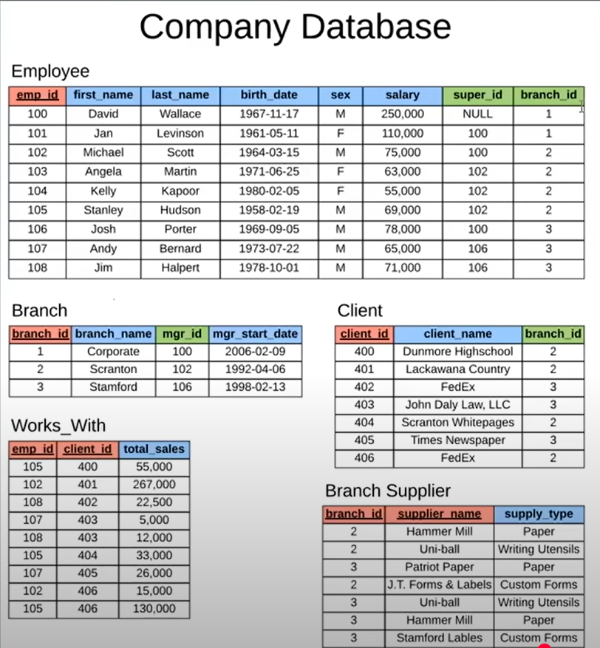

**Querying the company database**:

--Querying the company database-----------------------------

--Find all employees

select * from employee;

--Find all clients

select * from client

limit 100;

--Find all employees ordered by salary

select * from employee

ORDER BY salary DESC;

-- Find all employees by sex then name

select * from employee

ORDER BY sex DESC, first_name ASC, last_name DESC

limit 100;

-- Find the first 5 employees in the table

select * from employee

limit 5;

--Find first and last names of all employees

SELECT first_name, last_name

FROM employee

LIMIT 50;

--Find the forenames and surnames of all employees

SELECT employee.first_name AS forename, employee.last_name AS surname

FROM employee

LIMIT 50;

--Find out all different genders

SELECT DISTINCT employee.sex

FROM employee;

--Find out all different branch ids

SELECT DISTINCT employee.branch_id

FROM employee;

**! New Command**:

SELECT DISTINCT –Selects unique instances of specified column

# 7 Functions

--------FUNCTIONS---------

-- Find number of employees

SELECT COUNT(emp_id)

FROM employee;

-- Count number of employees that have supervisors

SELECT COUNT(super_id)

FROM employee;

--Find number of females employees born after 1970

SELECT COUNT(emp_id)

FROM employee

WHERE sex = 'F' AND birth_day >= '1971-01-01'

LIMIT 100;

--Find average salary of all employees who are male

SELECT AVG(salary)

FROM employee

WHERE sex = 'M';

--Find sum of all employee salary

SELECT SUM(salary)

FROM employee;

--Find how many males and howmany females there are

SELECT COUNT(sex), sex

FROM employee

GROUP BY sex;

--Find total sales of each salesman //added joins to this

SELECT works_with.emp_id, employee.first_name, SUM(works_with.total_sales) AS total_sales

FROM works_with

JOIN employee ON works_with.emp_id = employee.emp_id

GROUP BY works_with.emp_id, employee.first_name;

--How much mony has each client spent

SELECT works_with.client_id, client.client_name, SUM(works_with.total_sales) AS total_sales

FROM works_with

JOIN client ON works_with.client_id = client.client_id

GROUP BY works_with.client_id, client.client_name;

# 8 Wildcards

% = any number of characters, _ = one character

Implementation:

-----WILD CARDS-----

--- Find any clients who are an LLC

SELECT * FROM client

WHERE client_name LIKE '%LLC'; --if the client name has any number of chaacters then "LLC" at the end then return it;

--Find any branch suppliers thats in the label business

SELECT *

FROM branch_supplier

WHERE supplier_name LIKE '% label%' OR supplier_name LIKE '% lables%' ;

--Find any employee born in october

select * from employee;

SELECT *

FROM employee

WHERE birth_day LIKE '____-02%';

--Find any client who are schools

select * from client;

SELECT *

FROM client

WHERE client_name LIKE '%school%' ;

# 9 Unions

*Used to combine results of multiple select statements into one

----UNIONS-----

--Find a list of employee and baranch names

SELECT employee.first_name AS All_Names

FROM employee

UNION

SELECT branch.branch_name

From branch

UNION

SELECT client.client_name

FROM client;

--Find a list of all clients and branch supplier names and branch ids

SELECT client.client_name, client.branch_id

FROM client

UNION

SELECT branch.branch_name, branch.branch_id

From branch;

--Find a list of all money spent or earned by the company

SELECT employee.salary

FROM employee

UNION

SELECT works_with.total_sales

FROM works_with;

--essentially it just puts what ever is first above what ever is selected next into one table (bottom join)

# 10 Joins

*Used to combine rows from two or more tables based on related columns between them.

--------JOINS--------

INSERT INTO branch VALUES(4, 'Buffalo', NULL, NULL); --inserted for example branch with no mgr_id

-- Find all branches and corrisponding names of managers

SELECT employee.emp_id, employee.first_name, branch.branch_name

FROM employee

JOIN branch -- inner join //combines rows fom employee table and branch table with repect to shared column

ON employee.emp_id = branch.mgr_id; --columns that are in common

SELECT employee.emp_id, employee.first_name, branch.branch_name

FROM employee

LEFT JOIN branch -- left join combines all rows fom employee table and adds to it on the right branch table.

ON employee.emp_id = branch.mgr_id; --columns that are in common

SELECT employee.emp_id, employee.first_name, branch.branch_name

FROM employee

RIGHT JOIN branch -- Right join includes all rows fom branch table and adds employee table column to the right of it.

ON employee.emp_id = branch.mgr_id; --columns that are in common

--Full outer join combines both left and right join logic by grabbing all employees and all branches no matter if they met a certain condition

-- (ie employee.emp_id = branch.mgr_id)

-- Not function in MySQL

# 11 Nested Queries

*Involves using multiple select statements to get specific information

-------NESTED QUERIES--------

--Find names of all employees who have sold over 30000 to a single client

SELECT employee.first_name, employee.last_name

FROM employee

WHERE employee.emp_id IN(

    SELECT works_with.emp_id

    FROM works_with

    WHERE works_with.total_sales > 30000

);

--FIND all clients who are handled by the branch that

--Michael Scott manages

--Assume we know his ID

SELECT branch.branch_id

FROM branch

WHERE branch.mgr_id = 102;

SELECT client.client_name

FROM client

WHERE client.branch_id = (

    SELECT branch.branch_id

    FROM branch

    WHERE branch.mgr_id = 102

    LIMIT 1 --ensures its limited to one output

);

# 12 On Delete

Think of a case where we Michael Scott gets fired and now we have to delete his info from our database. We know that there are several tables that contain his id for example employee, branch and works_with table. Thus, we must use a method that appropriately deletes his name while updating all the dependent entries. There are two ways to approach this:  
1. **ON DELETE SET NULL**

* If an employee is deleted the entries associated with that employee is set to null

Example:

--recall this table we created earlier...

CREATE TABLE branch (

  branch_id INT PRIMARY KEY,

  branch_name VARCHAR(40),

  mgr_id INT,

  mgr_start_date DATE,

  FOREIGN KEY(mgr_id) REFERENCES employee(emp_id) ON DELETE SET NULL -- if the employee gets deleted then the mgr_id is set to NULL

);

DELETE FROM employee

WHERE emp_id = 102;

select * from branch;

select * from employee;

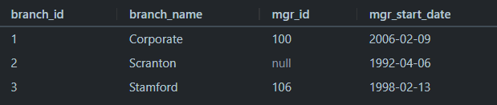

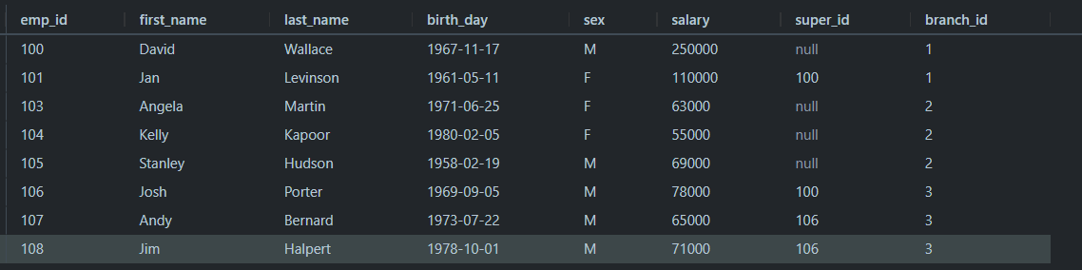

2. **ON DELETE CASCADE**

* -If an employee is deleted the entries associated with that employee is deleted from the database

Example:

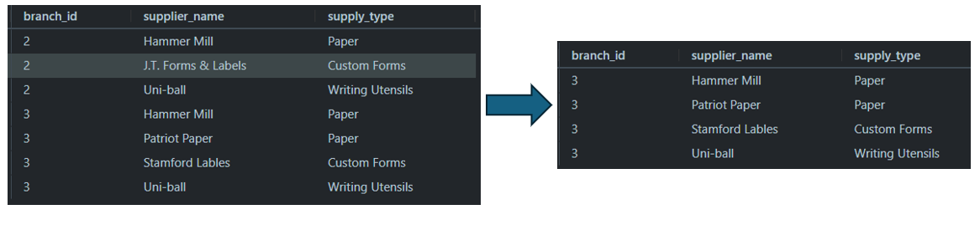

! NOTE: Its probably best to use **ON DELETE CASCADE** when the entry being deleted is a primary on a different table since a primary key cannot be set to null. Usually if it’s just a foreign key on other tables **ON DELETE SET NULL** is fine.

# 13 Triggers

*Is a block of SQL code which we can write which will define a certain action that should happen when a certain operation gets performed on the database.

*Triggers has to be defined on the command line (can’t use PopSQL) since we have to change the SQL delimiter

-----TRIGGERS------

CREATE TABLE trigger_test(

    message VARCHAR(100)

);

---THE FOLLOWING CAN ONLY BE DONE IN COMMAND LINE NOT IN PopSQL----

DELIMITER $$

CREATE

    TRIGGER my_trigger BEFORE INSERT

    ON employee

    FOR EACH ROW BEGIN

        INSERT INTO trigger_test VALUES('added new employee');

    END$$

DELIMITER ;

INSERT INTO employee

VALUES(109, 'Oscar', 'Martinez', '1968-02-19', 'M', 69000, 106, 3);

---THIS PART CAN BE DONE HERE (PopSQL)---

INSERT INTO employee

VALUES(109, 'Oscar', 'MArtinez', '1968-02-19', 'M', 69000, 106, 3);

select * from trigger_test

--This part is done on command line---

DELIMITER $$

CREATE

    TRIGGER my_trigger_2 BEFORE INSERT

    ON employee

    FOR EACH ROW BEGIN

        INSERT INTO trigger_test VALUES(NEW.first_name);

    END$$

DELIMITER ;

---This part is done on PopSQL

INSERT INTO employee

VALUES(110, 'Kevin', 'Malone', '1978-02-19', 'M', 69000, 106, 3);

---Conditional trigger (if else)

--THIS is done on the command line

DELIMITER $$

CREATE

    TRIGGER my_trigger_3 BEFORE INSERT

    ON employee

    FOR EACH ROW BEGIN

         IF NEW.sex = 'M' THEN

               INSERT INTO trigger_test VALUES('added male employee');

         ELSEIF NEW.sex = 'F' THEN

               INSERT INTO trigger_test VALUES('added female');

         ELSE

               INSERT INTO trigger_test VALUES('added other employee');

         END IF;

    END$$

DELIMITER ;

--This can be done on PopSQL

INSERT INTO employee

VALUES(111, 'Pam', 'Beesly', '1988-02-19', 'F', 69000, 106, 3);

select * from trigger_test;

--In addition to BEFORE INSERT we can do BEFORE UPDATE, BEFORE DELETE or

--AFTER INSERT we can do AFTER UPDATE, AFTER DELETE

--Triggers can be deleted aswell...

DROP TRIGGER my_trigger;

# 14 ER Diagrams Introduction

\***Entity**: An object we want to model and store info about.

\***Primary Key**: An attribute(s) that uniquely identify an entry in the database table. Indicated by underlining the name.

\***Attributes**: Specific pieces of info about an entity

\***Composite Attribute**: An attribute that can be broken up into sub-attributes

\***Multi-Valued Attribute**: An attribute that can have more than one value

\***Derived Attribute**: An attribute that can be derived from other attributes

\***Relationships**: Defines a relationship between two entities

\***Relationship Attribute**: Attribute about the relationship (stored on relationship)

\***Relationship Cardinality**: Number of instances of an entity from a relation that can be associated with the relation. Different types:

1:1 One to one relationships: E.g. Class can only have one subject, and one subject can only have one class

1:N One to many relationships: E.g. Class can have many exams, but exam has one class

N:M: Many to many relationships: E.g. Many students can take many classes

\***Weak Entity**: An entity that cannot be uniquely identified by its attributes alone

\***Identifying relationship**: A relationship that serves to uniquely identify weak entity

EXAMPLE:

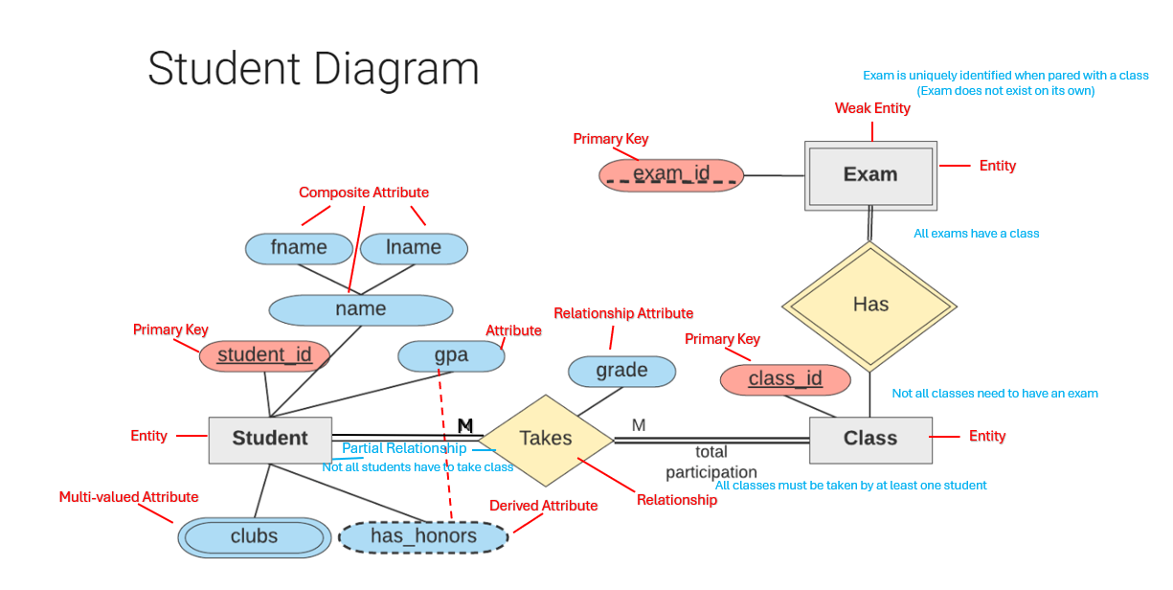

# 15 Designing an ER Diagram

Given information:

**Company Data Storage Requirements**

The company is organized into branches. Each branch has a unique number, a name, and a particular employee who manages it.

The company makes its money by selling to clients. Each client has a name and a unique number to identify it.

The foundation of the company is its employees. Each employee has a name, birthday, sex, salary and a unique number.

An employee can work for one branch at a time, and each branch will be managed by one of the employees that work there. We’ll also want to keep track of when the current manager started as manager.

An employee can act as a supervisor for other employees at the branch, an employee may also act as the supervisor for employees at other branches. An employee can have at most one supervisor.

A branch may handle a number of clients, with each client having a name and a unique number to identify it. A single client may only be handled by one branch at a time.

Employees can work with clients controlled by their branch to sell them stuff. If necessary multiple employees can work with the same client. We’ll want to keep track of how many dollars’ worth of stuff each employee sells to each client they work with.

Many branches will need to work with suppliers to buy inventory. For each supplier we’ll keep track of their name and the type of product they’re selling the branch. A single supplier may supply products to multiple branches.

**Approach**: Just go through each line convert it to ER diagram. Then Find the relationships between all the entities. Result:

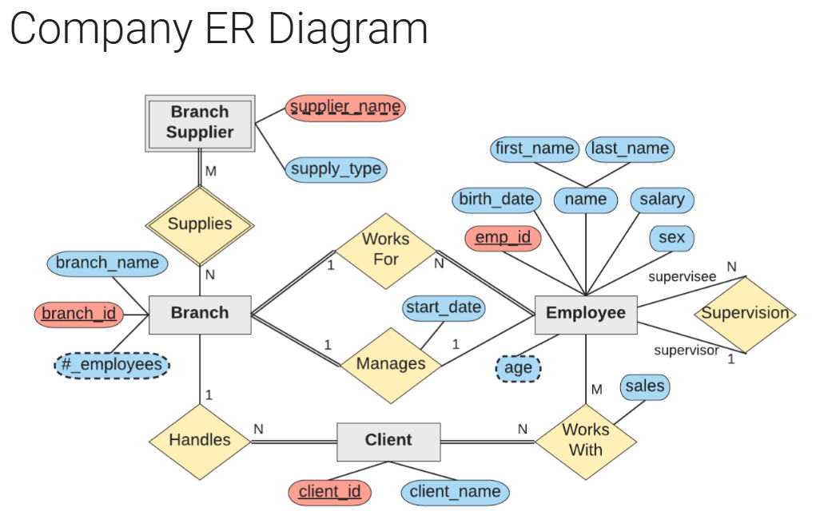

There are different conventions for ER diagrams. For example:  
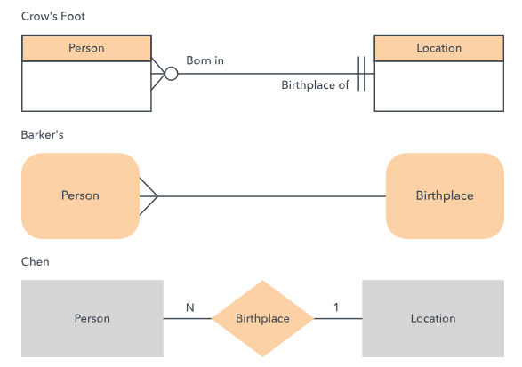  
  
I believe we used Chen convention. I recommend looking at the following website that goes over the different conventions. They all follow the same logic but not all companies would use the same. (For example, I prefer Crow’s foot as its arguably more clean

<https://www.lucidchart.com/pages/er-diagrams>

# 16 Converting ER Diagrams to Schemas

**STEP 1: Mapping of regular entity types**

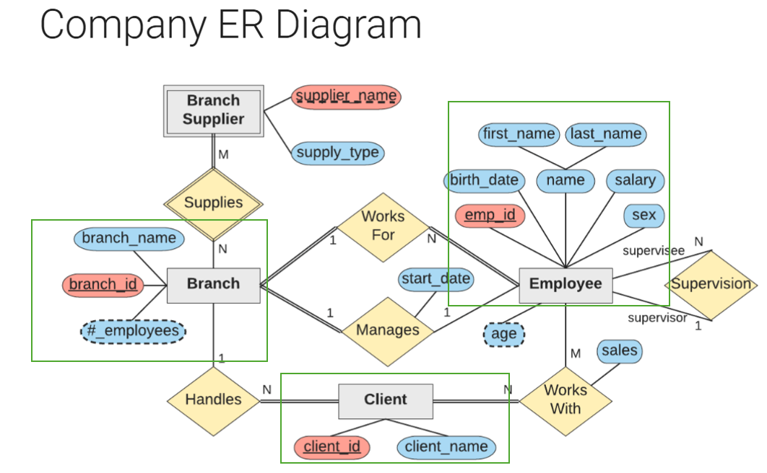

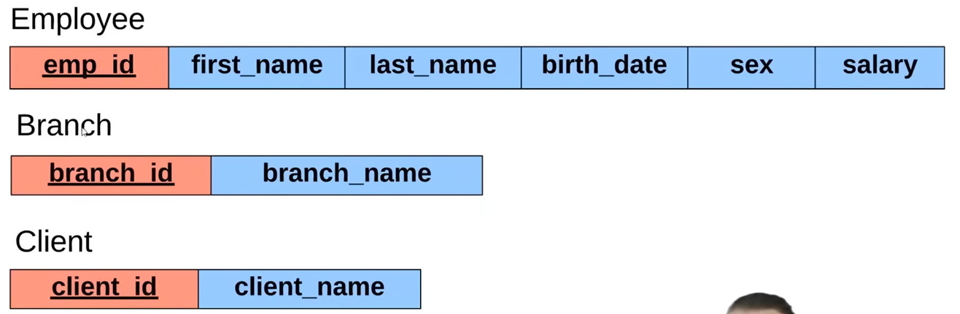

**STEP 2: Mapping of weak entity types**

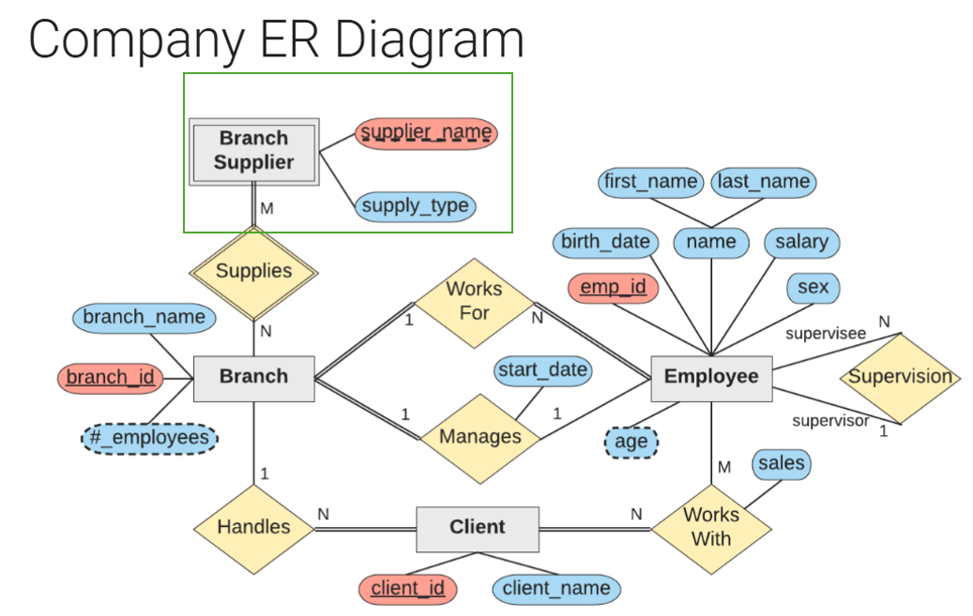

! Note: the primary key of the new relation should be the partial key of the weak entity (supplier_name) plus the partial key of the primary key of its owner (branch_id).

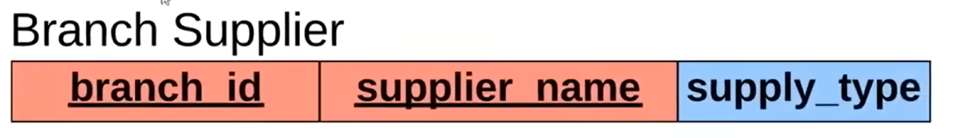

**STEP 3: Mapping of Binary 1:1 Relationships**

! Note: Include one side of the relationship as a foreign key in the other. Favor the total participation.

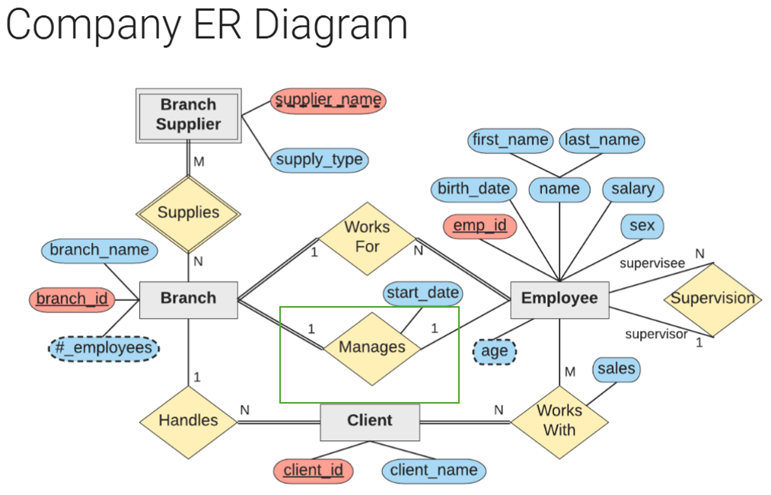

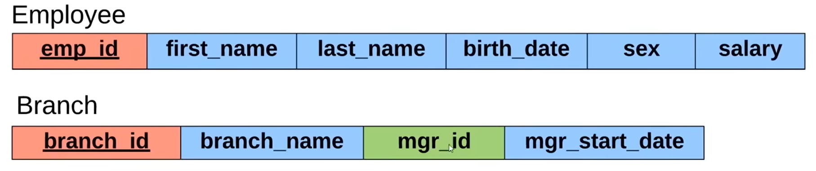

**STEP 4: Mapping of Binary 1:N Relationships**

! Note: Include the 1 sides primary key as foreign key on the N side relation (table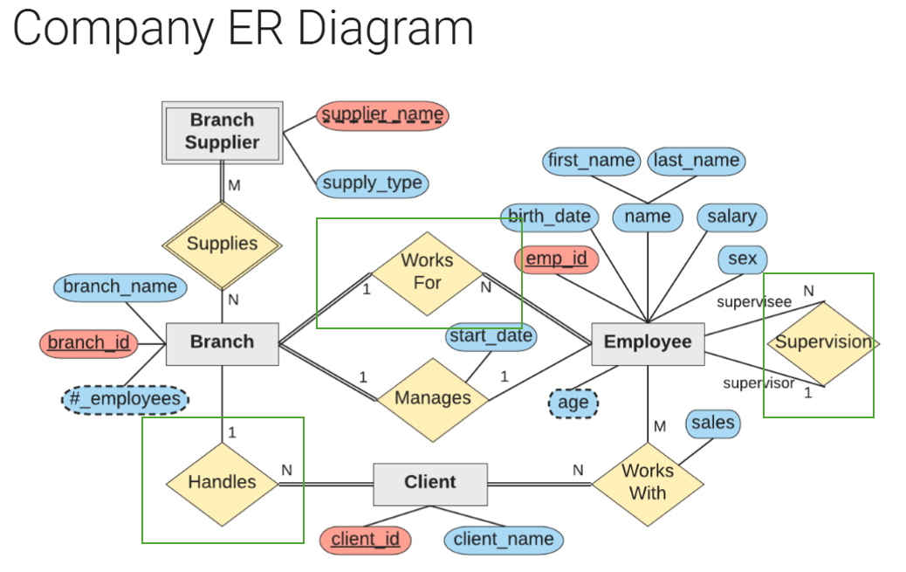

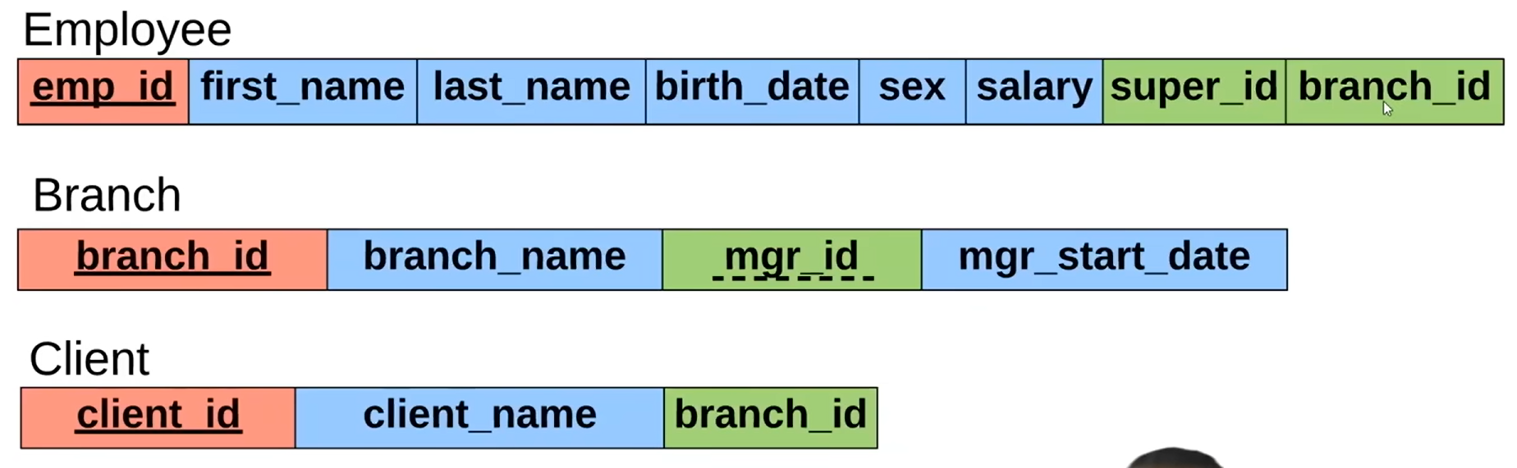

**STEP 5: Mapping of Binary M:N Relationships**

! Note: Create new relation table whose primary key is combination of both entities primary key also include relationship attributes

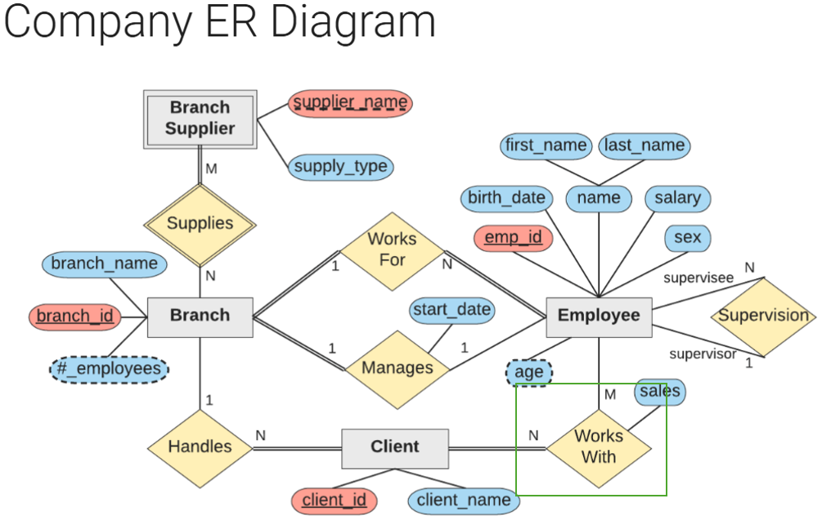

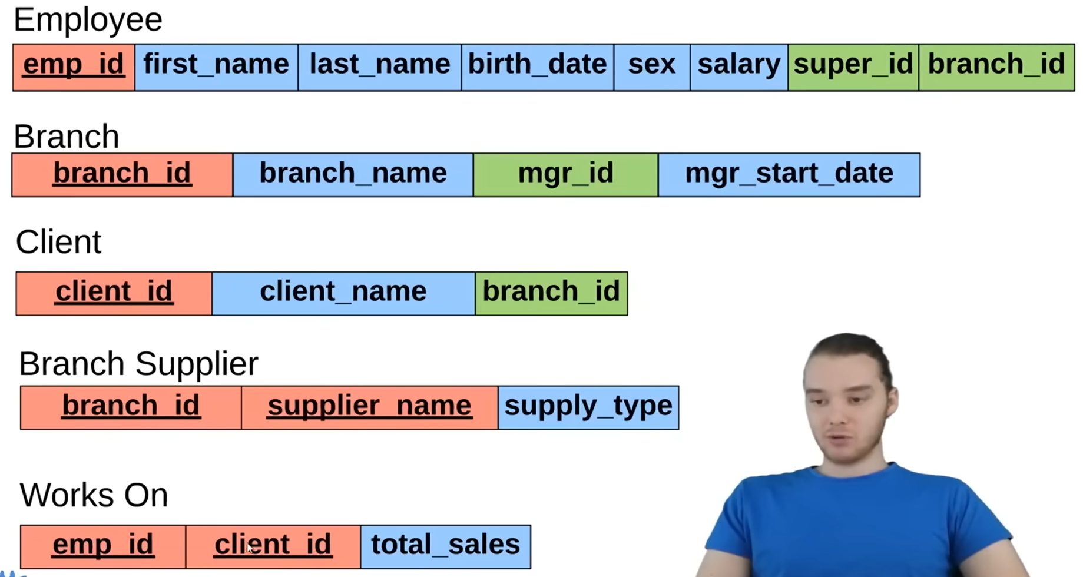

Result:

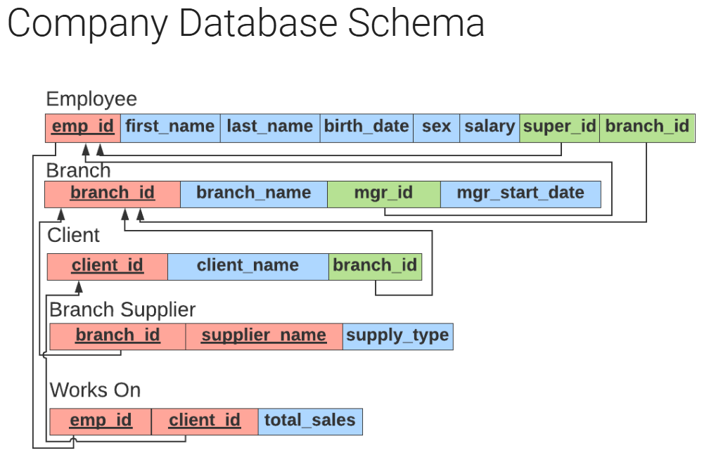

**STEP 6: Create the database**

